Report Design Steps

- Make SQL Query which will you use in your Report.
Use: TOAD, PL SQL, or any Query Execution Tools
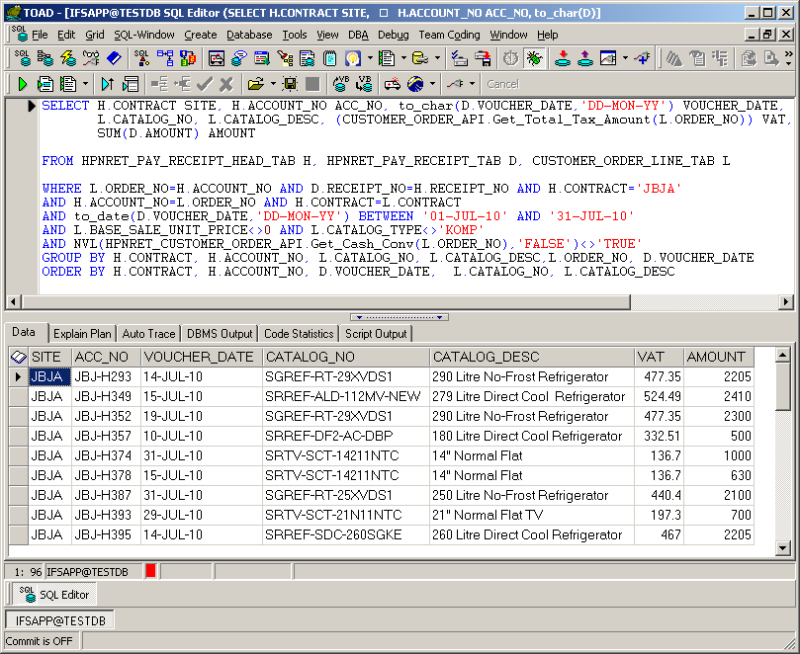
- Take a Folder/Directory for Your New Report.
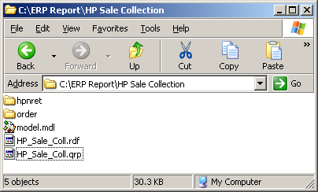
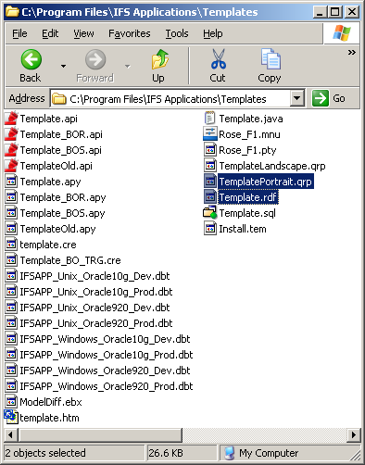
- Open Design Tools from IFS Application
(Start → Programs → IFS Application → Developments Tools → Design)
- File → New Project
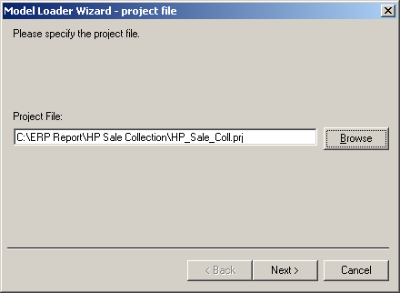
Click on Browse to Set the Path to Save the Project File, give a Name for your Project. Eg: HP_Sale_Coll
- Click on Next → Choosing Model File, Click on Browse and Select the Model File which has been given by IFS (model.mdl)
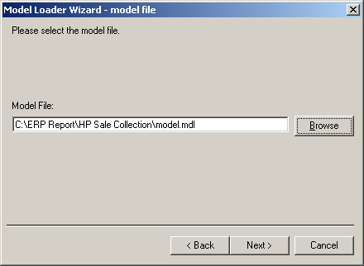
- Click Next → On Top of the Grid Click on Right Column and enter the Module Name, ORDER for Customer Orders and HPNRET for HPNRET.
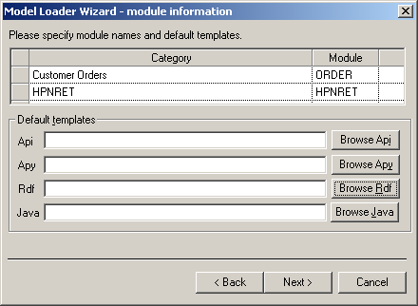
Then Click on button Browse rdf.
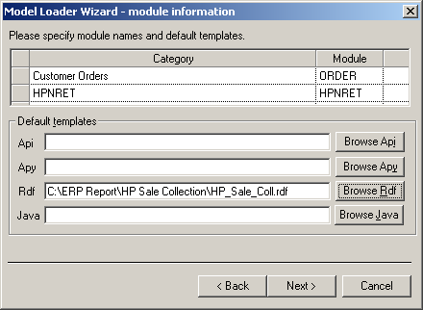
Note: You will find the Sample/Template RDF file in IFS installed directory Named “Template.rdf”, Find it and copy to your Project Directory. And Rename as Your Desired Report Name, without any Space or any special Character.
Eg: HP_Sale_Coll.rdf
- Click on Next → You will get a New Window, pls check that all information are correct Click Finish
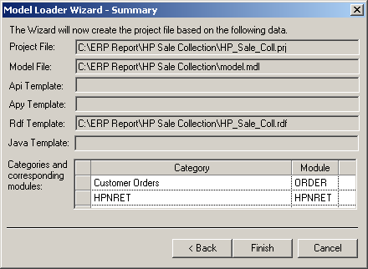
- New Information Message Window will come, Click Yes →
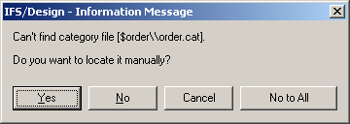
Then find the hpnret.cat File which is given by IFS, then wait for a while, another new and same type of Window will come Click Yes →
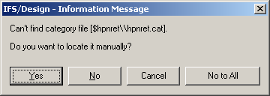
Find order.cat File
- Your Project is ready to Add Data Fields to Customize.
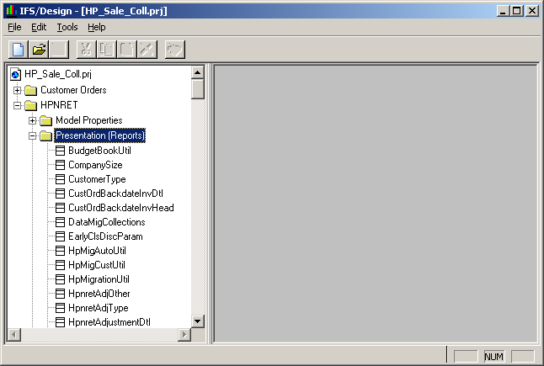
Look over the Left Side Tree → HPNRET → Presentation (Reports) → HpnretCustomerOrder →
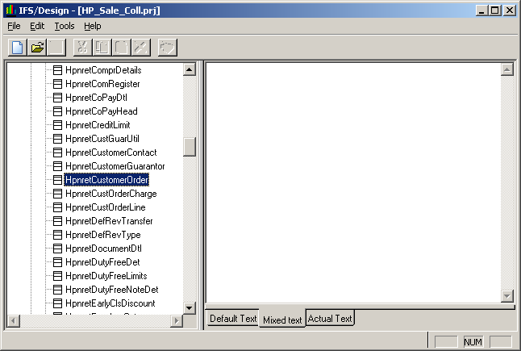
Double Click on Last Item.
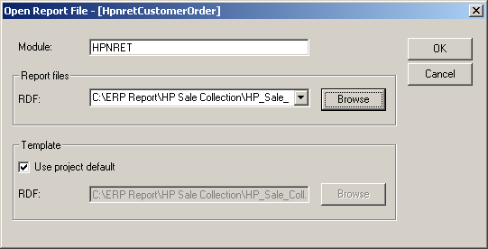
Click on Browse in Report Files Frame, Select the RDF file which you have copied and renamed in your Project Folder. Then Click OK
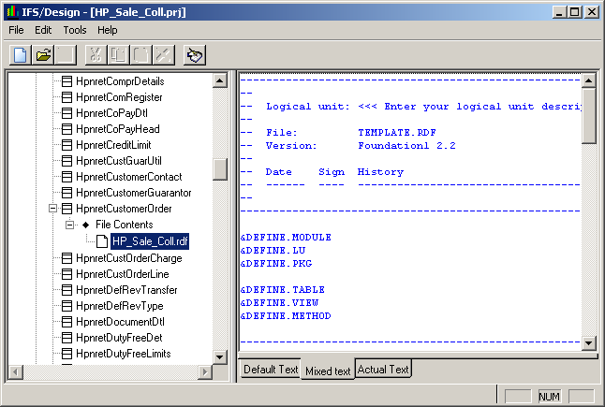
- You will have one step from your Last Item which you have Double Clicked,
File Contents → Right Click and Click on Properties →
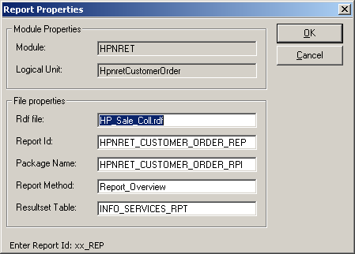
Modify the Report ID which is Unique. Default ID will come as HPNRET_CUSTOMER_ORDER_REP
Rename as HPNRET_HP_SALE_COLL_REP and also rename Package name. Default Package Name will come as HPNRET_CUSTOMER_ORDER_RPI rename as HPNRET_HP_SALE_COLL_RPI
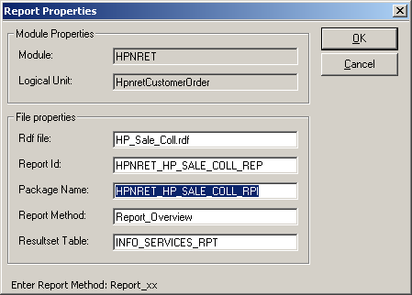
Click on File Menu → Save (F12) → Check the Path is Correct where is your RDF is exists then Click OK
- Right Click again in HpnretCustomerOrder Left side Tree and Click on Reload, now you will have so many things which you have been expecting.
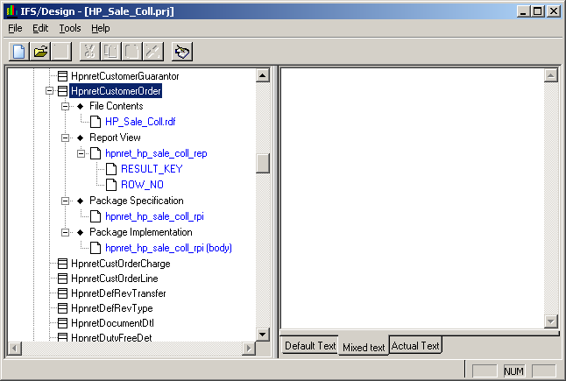
- Find Report View on Left Tree → Click on hpnret_hp_sale_coll_rep → Click on Right Panel then Right Click on that Panel → Edit.
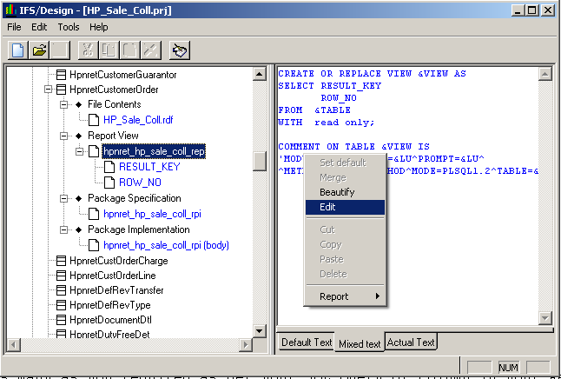
New window will come
In Report Tab → Change the Report Title, eg: HP Sale Collection
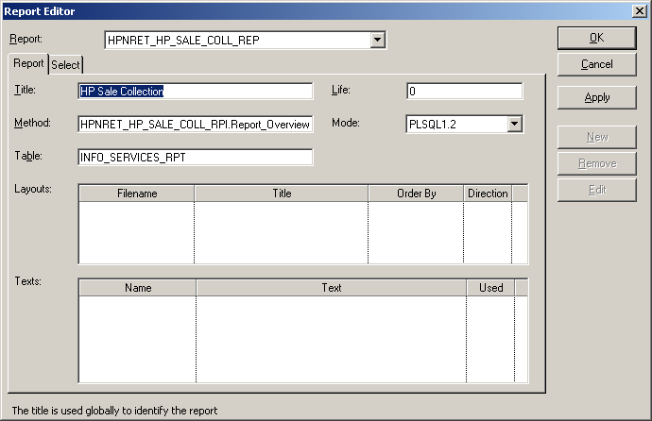
In Select Tab → Click on New button →
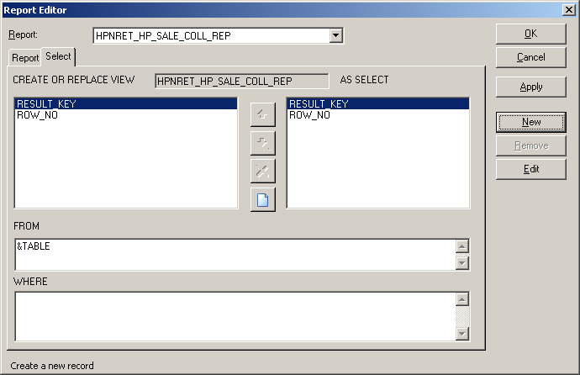
New and Enter your Data Field Name as many as you required as per your SQL Query or Column in your Report (including Parameter which will used in your Query)
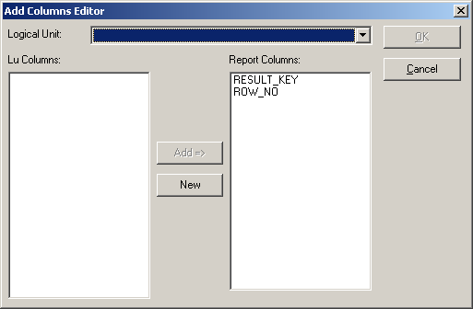
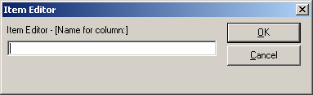
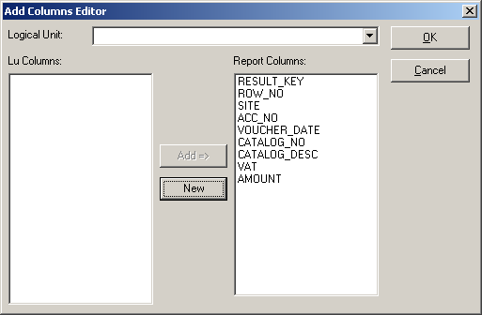
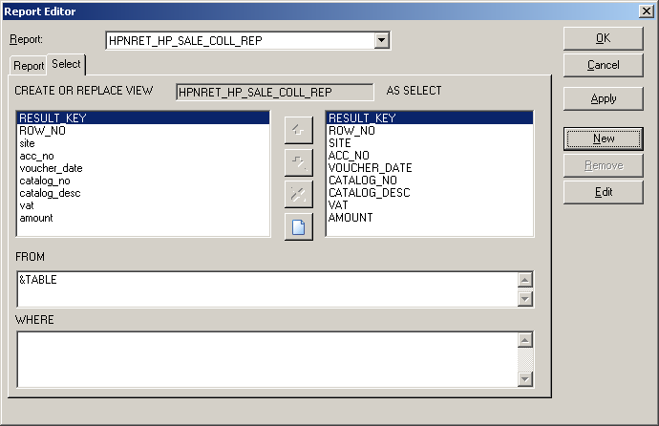
After Entering Data Fields name Just Click on OK, you will come back to Report Editor (Select Tab)
- You will see the Fields Select each an every item from Right side List Items and Click Edit button to Set Column Data Type.
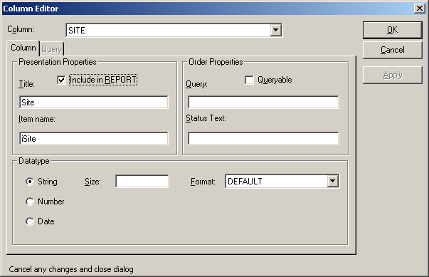
And have to set Queryable Column so Select the Field and Click on Edit if you are not in Edit Column Window, Tick on Queryable, Enter the Remarks bellow the Check box.
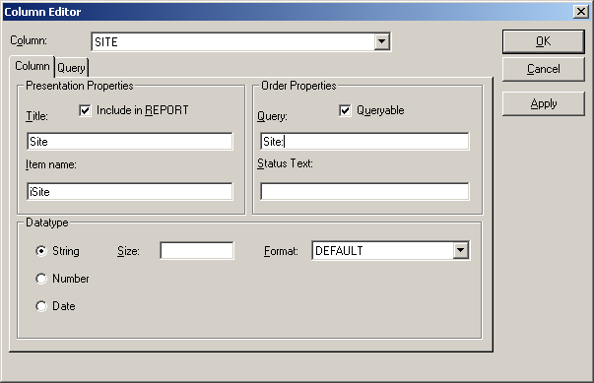
Then Goto Query Tab and Choose your option or as you required, like mandatory, LOV, etc
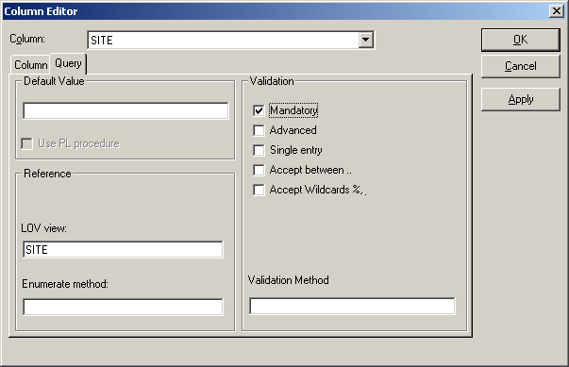
Then we have to set the actual field name which is compatible with Temporary table. So select each an every item and Double Click and give New Name.
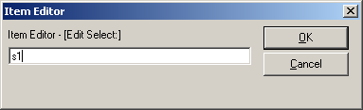
Note: For String: s1, s2, s3, s4, up to s50
For Number: n1, n2, n3, n4, up to n30
For Date: d1, d2, d3, d4, up to d19
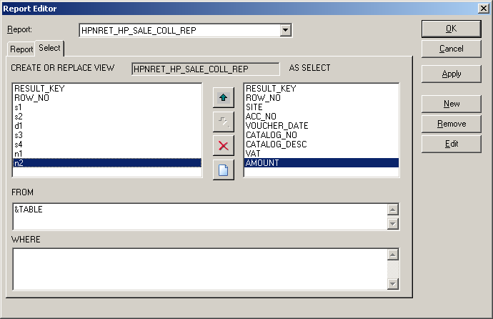
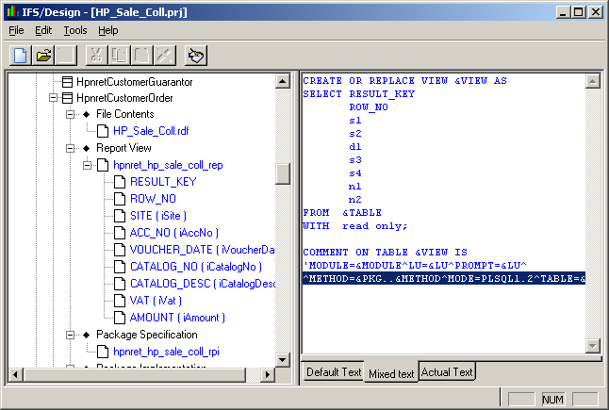
- Open PL SQL Developer → Click Open → Command File → Find your RDF file and Open.
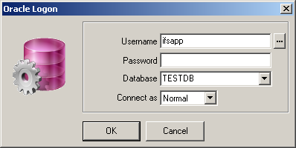
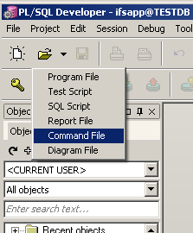
Scroll Down and Find PACKAGE IMPLEMENTATION
Enter your New Required Variable for your package under
IS

CURSOR <<cursor name>> IS
YOUR SQL QUERY;

Use your CURSOR to Retrieve Values from your Designed Query and Store in CURSOR.

BEGIN
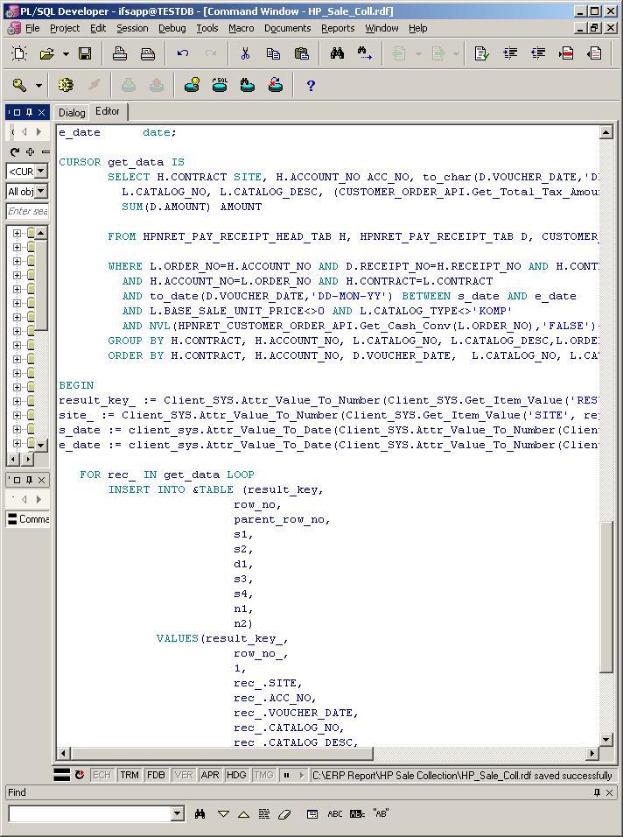
- Find the result_key_ and Enter your New Parameter Simply Copy the existing line and rename as your variable
Eg: Default: result_key_ := Client_SYS.Attr_Value_To_Number(Client_SYS.Get_Item_Value('RESULT_KEY', report_attr_));
For Date use extra parameter like: payment_start_date_ := client_sys.Attr_Value_To_Date(Client_SYS.Get_Item_Value('S_DATE', parameter_attr_));
Otherwise for all is same as Default Style
- After Entering Parameter Get Data From CURSOR and INSERT to Temporary Report Table

FOR <<alias>> IN <<cursor name>> LOOP
INSERT INTO &TABLE (result_key,
row_no,
parent_row_no,
n1,
s1,
n2,
n3,
n4,
n5)
VALUES (
result_key_,
row_no_,
1,
alias.ROWNUM_,
alias.CONTRACT,
alias.DISCOUNT,
alias.VAT,
alias.NSP,
alias.RSP);
row_no_:= row_no_ + 1;
END LOOP;

- Press F8 to Execute and Deploy RDF to Database. If there is no Error in your Package Body, then Congress. We are successfully Deployed Report Package and Now Ready to Design the Report for Printing and Display Data
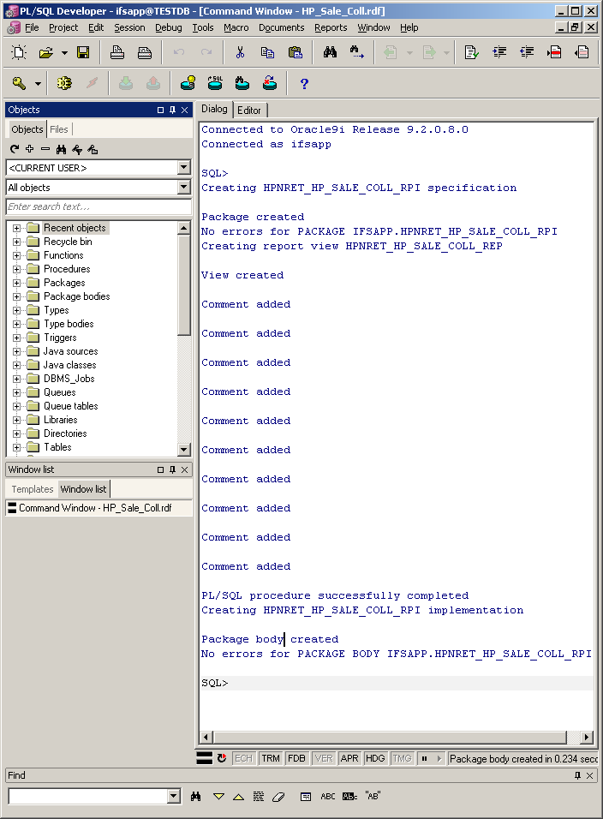
- Open IFS Report (Start → Programs → IFS Application → Developments Tools → Report)
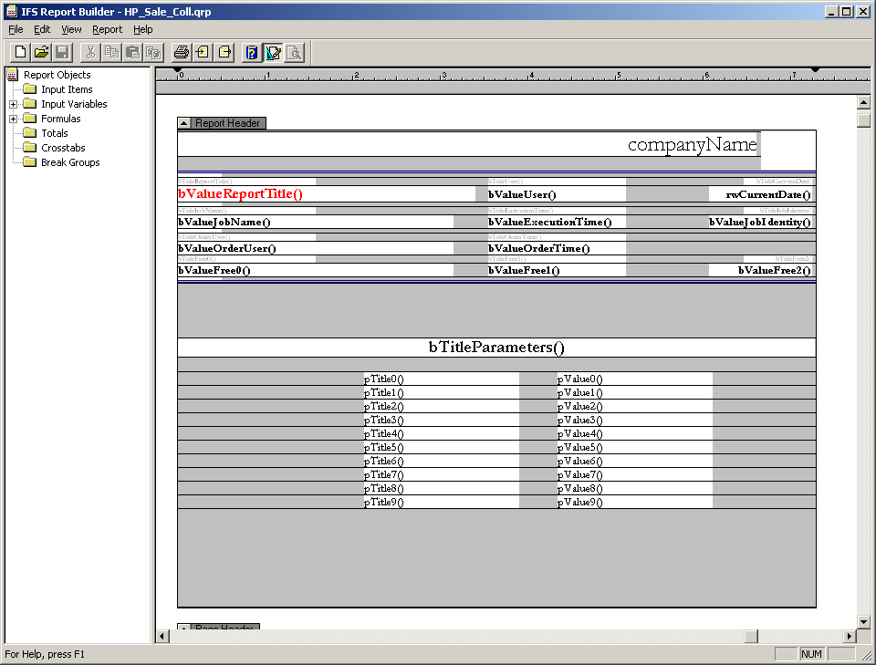
- Find QRP from IFS Installed Templates Folder:
TemplatePortrait.qrp is for Portrait A4 Paper
TemplateLandscape.qrp is for Landscape A4 Paper
Rename as hpnret_hire_sale_rtp_rep.qrp which is Similar with your Report ID, Open with Report Tools
File Menu → Open → Select File Type QRP → Select your QRP and click OK
- Click on Left Panel Tree on Input Items → Right Click and Click New →
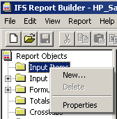
Enter Column i Variable Name and Select Data Type then and Click on New button and put all items and don’t forget about Data Type Selection.
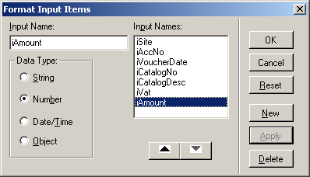
Then Go to Right Panel Details Part and Drag & Drop i Variable Items which already you have entered.
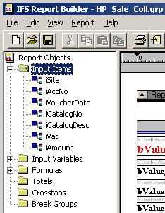
After Putting all items Save the Report.
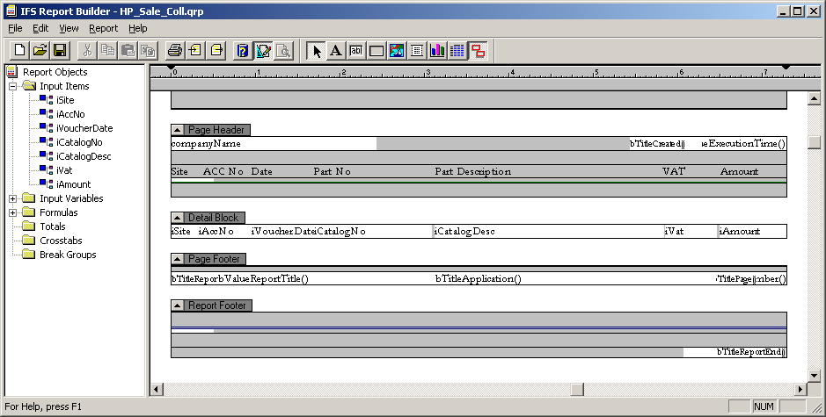
Formatting: Font
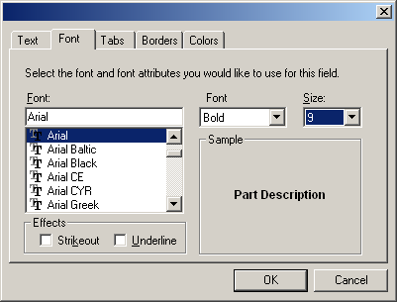
Formatting: Text
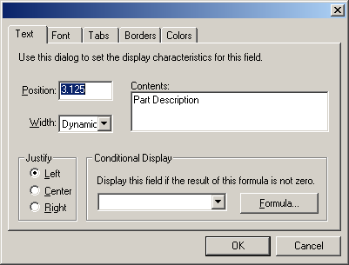
Formatting: Tabs/Borders/Colors, Just click on the Tabs and Change your Required Settings.
And Copy/Cut the QRP and Paste into your System Default Report Directory/Folder to View the Report.
- Report Layout Registration, Open IFS Admin (Start → Programs → IFS Application → Administrative Tools → Admin)
In Tree Menu → IFS Applications → Foundation1 Administration → Info Services → Report Layout Registration.
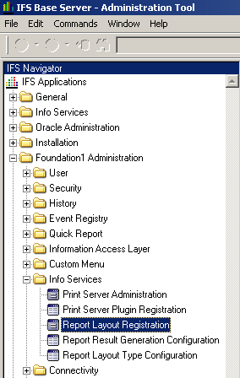
Click on Find and Enter your Report ID: HPNRET_HP_SALE_COLL_REP, One Line will come if not Comes then Click for a New Line, Enter your QRP name, Then Layout Title (It can be anything),
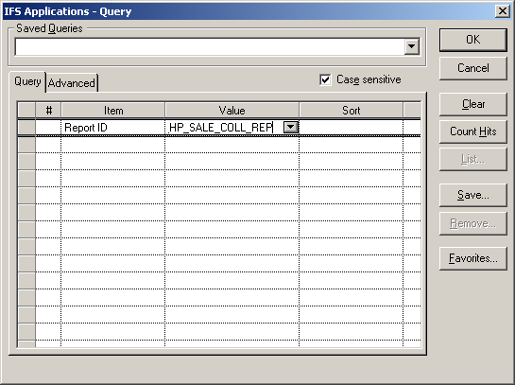
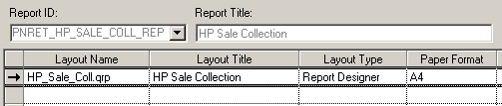
Select Report Builder from Drop Down, Select Page Size (A4) and Save the Line
- View the Report.
Open Admin Tools (See Last Step to Know About Admin Tools)
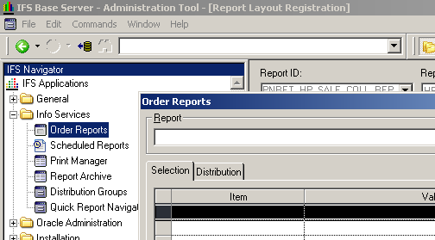
In Tree Menu → IFS Applications → Info Services → Order Reports
Select Your Report From Report Drop Down you will see the Queryable Fields bellow Grid.
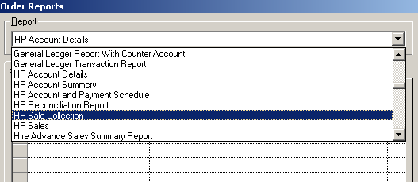
Enter the Parameter Value and Click OK.
- You will get a Report Print Window.
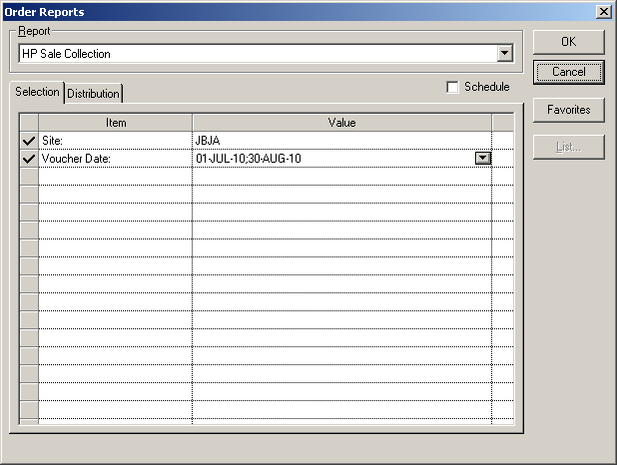
Select Layout if you have Multiple Layout.
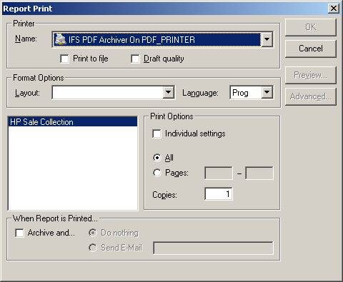
Click OK or Preview to View the Report. If you don’t have the Buttons Active, then there is some problem or your Query do not have any Result.

THANK YOU
Mohtasim Md. Monzur Rahman
Date: Sunday, October 31, 2010

